Q1: Write a C program to perform Matrix Multiplication

SOLUTION:

CODE:

1. #include<stdio.h>
2. #include<stdlib.h>
3. **int** main(){
4. **int** a[10][10],b[10][10],mul[10][10],r,c,i,j,k;
5. system("cls");
6. printf("enter the number of row=");
7. scanf("%d",&r);
8. printf("enter the number of column=");
9. scanf("%d",&c);
10. printf("enter the first matrix element=\n");
11. **for**(i=0;i<r;i++)
12. {
13. **for**(j=0;j<c;j++)
14. {
15. scanf("%d",&a[i][j]);
16. }
17. }
18. printf("enter the second matrix element=\n");
19. **for**(i=0;i<r;i++)
20. {
21. **for**(j=0;j<c;j++)
22. {
23. scanf("%d",&b[i][j]);
24. }
25. }
27. printf("multiply of the matrix=\n");
28. **for**(i=0;i<r;i++)
29. {
30. **for**(j=0;j<c;j++)
31. {
32. mul[i][j]=0;
33. **for**(k=0;k<c;k++)
34. {
35. mul[i][j]+=a[i][k]*b[k][j];
36. }
37. }
38. }
39. //for printing result
40. **for**(i=0;i<r;i++)
41. {
42. **for**(j=0;j<c;j++)
43. {
44. printf("%d\t",mul[i][j]);
45. }
46. printf("\n");
47. }
48. **return** 0;
49. }

O/P:

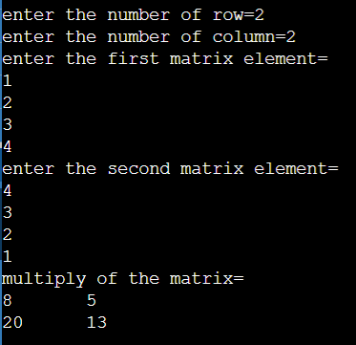

Q2: Write a C program to find Odd or Even number from a given set of numbers  
  
SOLUTION:

CODE:

#include<stdio.h>

int main() {

int number;

printf("Enter any integer: ");

scanf("%d",&number);

if(number % 2 ==0)

printf("%d is even number.",number); else

printf("%d is odd number.",number);

return 0;

}

O/P:  
  
  
  
  
Q3: Write a C program to find Factorial of a given number without using Recursion  
  
SOLUTION:

CODE:

1. #include<stdio.h>
2. int main(){
3. int i,f=1,num;
5. printf("Enter a number: ");
6. scanf("%d",&num);
8. for(i=1;i<=num;i++)
9. f=f*i;
11. printf("Factorial of %d is: %d",num,f);
12. return 0;
13. }

O/P:  
  
  
Q4: Write a C program to find Fibonacci series without using Recursion

SOLUTION:

CODE:

1. #include<stdio.h>
2. **int** main()
3. {
4. **int** n1=0,n2=1,n3,i,number;
5. printf("Enter the number of elements:");
6. scanf("%d",&number);
7. printf("\n%d %d",n1,n2);//printing 0 and 1
8. **for**(i=2;i<number;++i)//loop starts from 2 because 0 and 1 are already printed
9. {
10. n3=n1+n2;
11. printf(" %d",n3);
12. n1=n2;
13. n2=n3;
14. }
15. **return** 0;
16. }

O/P:  
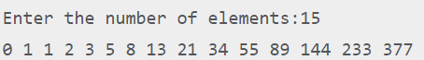

Q5: Write a C program to find Fibonacci series using Recursion

SOLUTION:

CODE:

1. #include<stdio.h>
2. **void** printFibonacci(**int** n){
3. **static** **int** n1=0,n2=1,n3;
4. **if**(n>0){
5. n3 = n1 + n2;
6. n1 = n2;
7. n2 = n3;
8. printf("%d ",n3);
9. printFibonacci(n-1);
10. }
11. }
12. **int** main(){
13. **int** n;
14. printf("Enter the number of elements: ");
15. scanf("%d",&n);
16. printf("Fibonacci Series: ");
17. printf("%d %d ",0,1);
18. printFibonacci(n-2);//n-2 because 2 numbers are already printed
19. **return** 0;
20. }

O/P:  
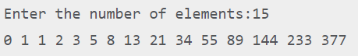  
  
  
Q6: Write a C program to find Factorial of a given number using Recursion  
SOLUTION:

CODE:

1. #include<stdio.h>
3. **long** factorial(**int** n)
4. {
5. **if** (n == 0)
6. **return** 1;
7. **else**
8. **return**(n * factorial(n-1));
9. }
11. **void** main()
12. {
13. **int** number;
14. **long** fact;
15. printf("Enter a number: ");
16. scanf("%d", &number);
18. fact = factorial(number);
19. printf("Factorial of %d is %ld\n", number, fact);
20. **return** 0;
21. }

O/P:  
